Visit to Boston from the Women’s Affairs Division of the LDP

On Sept. 1, members of the Women’s Affairs Division of the Liberal Democratic Party came to Boston to learn about local policies against child abuse. With the goal of improving Japan’s child abuse policies, the team met with members of JB Line, a support group for Japanese nationals in New England, to hear about child abuse and child abuse policies in Boston and to exchange opinions. They also visited Boston Children’s Hospital and Massachusetts General Hospital.

Greetings from Deputy Consul General Watanabe.
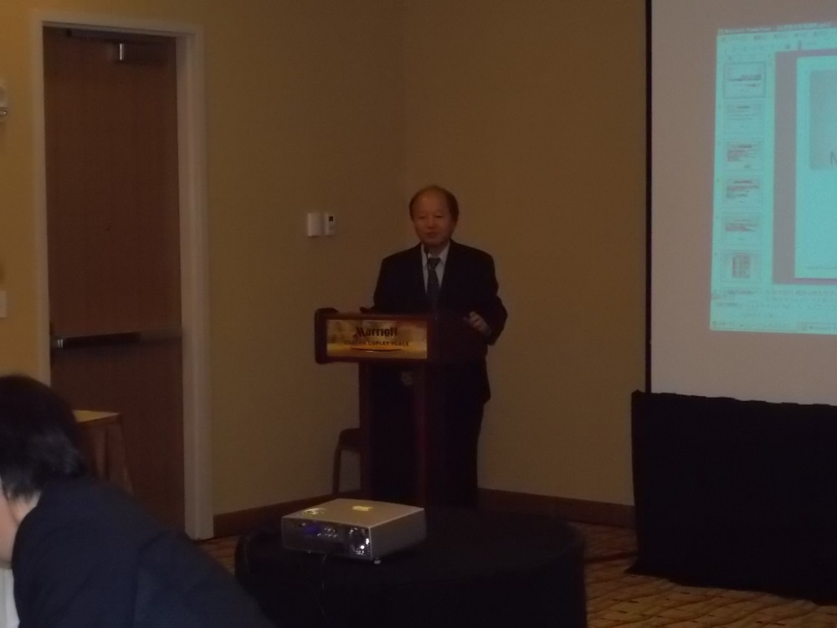
Participants engage in exchange of opinions.
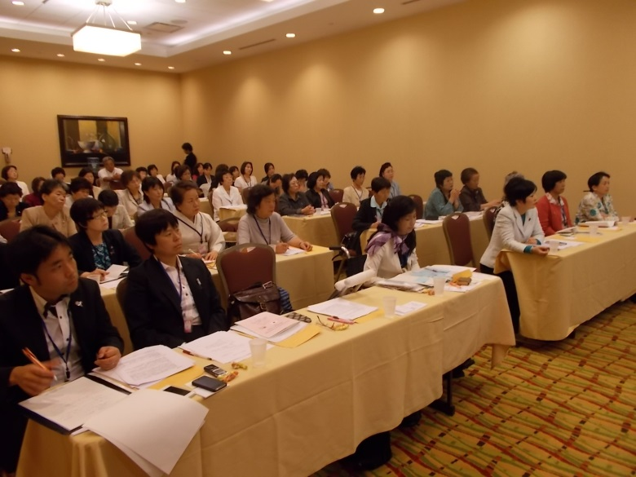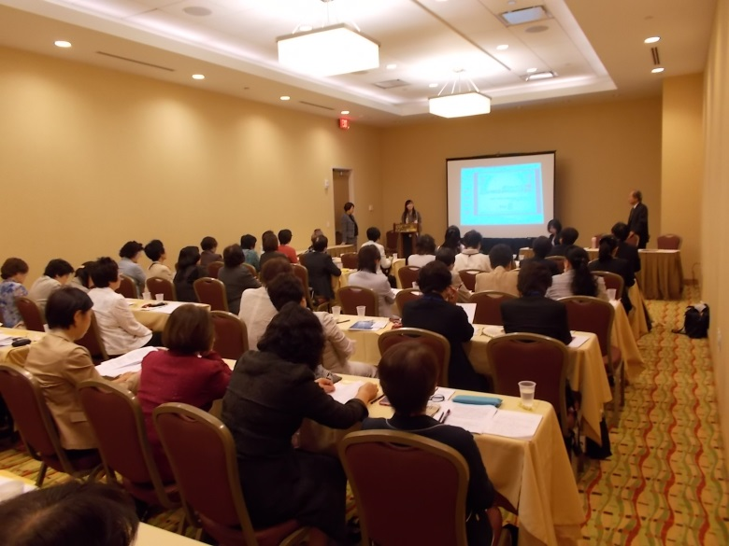

Lecture by Dr. Mai Uchida at Massachusetts General Hospital.
